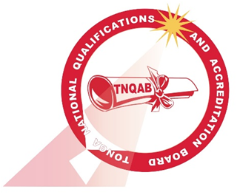

DEVELOPMENT PROCESS CHECKLIST
for
NATIONAL QUALIFICATIONS
Note:
- This form is also attached as Appendix L, Guidelines for National Qualifications Development and Registration on TQF 2018
- This checklist tool is to ensure consistency and completeness in developing a national qualification.

Instructions: Use a tick (√) to indicate the processes and/or stages which you have completed. Make sure that all processes are completed.

National Qualification Development Processes | Click inside the box to insert a tick. Click again to remove tick.
Have you researched the need for a new National Qualification? (You should have evidence of this) | ☐
Have you consulted TNQAB (in writing) about your proposal to develop a new National Qualification? | ☐
Have you considered TNQAB’s feedback before proceeding? | ☐
Have you established an ITAC or equivalent to assist and advise on the development of the national qualification? | ☐
Have you identified the scope and relevancy of the proposed National Qualification? | ☐
Have you conducted functional analysis to identify required competencies for award of the National Qualification? | ☐
Have you written up the draft descriptor of the National Qualification according to Section 4.3 of these Guidelines? | ☐
Have you conducted international benchmarking of the proposed National Qualification? (You should have evidence of this) | ☐
Have you conducted stakeholder validation of the draft National Qualification descriptor? (You should have evidence of this) | ☐
Have you addressed the feedback from the validation process? (You should have evidence of this) | ☐
Have you obtained sector/industry endorsement (in writing) of the proposed National Qualification? | ☐
Have you checked and compiled all the information for the application to register the proposed National Qualification on the Tonga Qualifications Framework? | ☐

